**We will create a button and apply ‘click event’ on it and create a function for it in App.js file ↓ 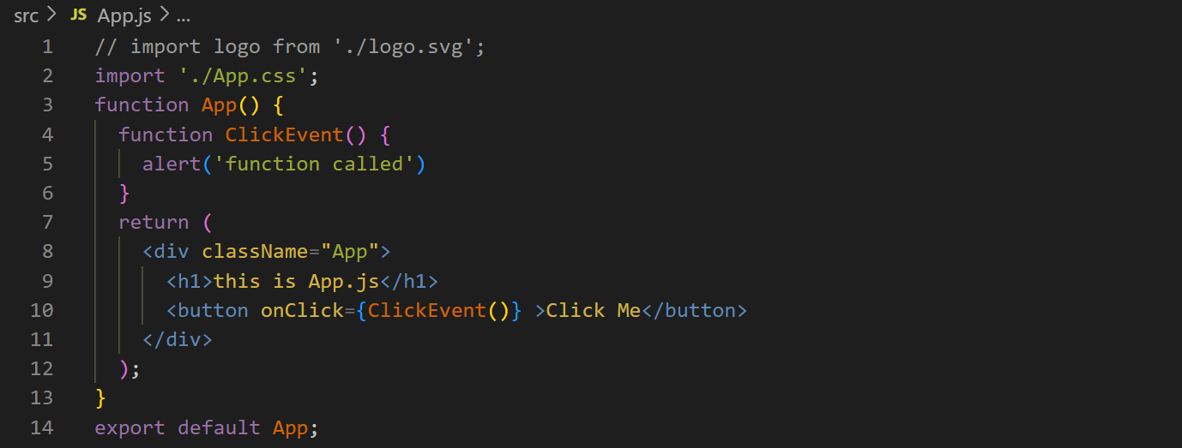you will see the function “ClickEvent” will be called without pressing the button only on refreshing the page, because, it doesn’t know when it should call the function. To prevent it, write the function name without () ↓ 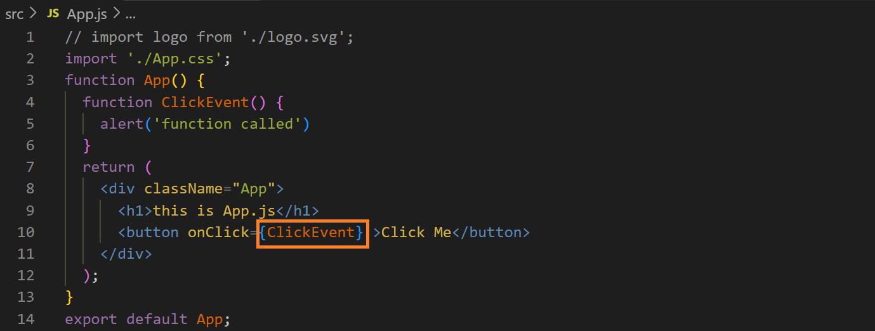We can use arrow function, without creating a function, as the value of the attribute “onClick” ↓**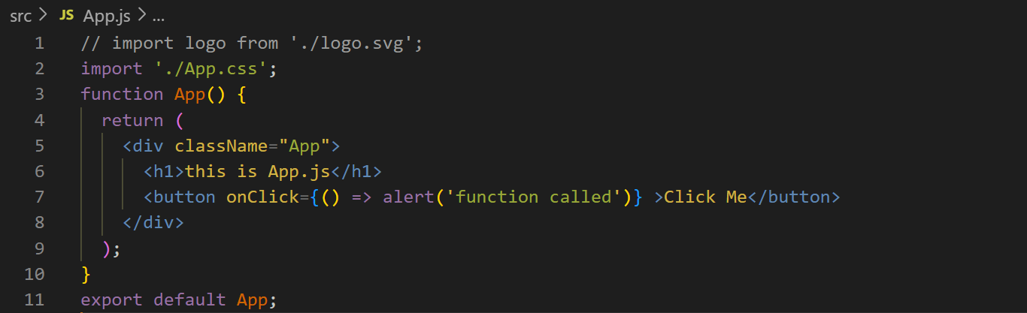

**We don’t use variables to declare a variable, if we declare a function with “let” and redeclare in the function “ClickEvent”, it will not work, i.e., the variable will not be redeclared ↓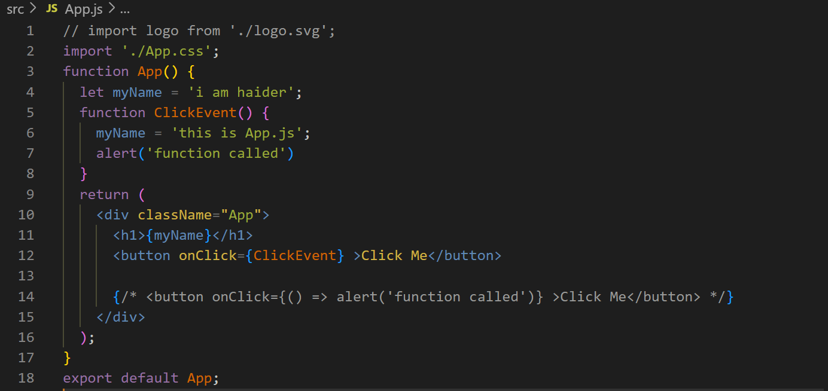copy the code and run it to see the result ‘I am haider’ will not be replaced by ‘this is App.js’.**

**Therefore we use ‘states’ & ‘props’.**